**AMERICAN INTERNATIONAL UNIVERSITY-BANGLADESH**

**Faculty of Science and Technology**



**Course Title: Data Communication**

**Mid Term Lab Assignment**

|  |  |
| --- | --- |
| ***Submitted by:***  **Name: Shifat, Shadril Hassan**  **ID: 20-42451-1**  **Section: G**  **Program: BSc CSE**  **Semester: Spring 2021-2022**  **Date: 19 March, 2022** | ***Submitted to:***  **Course Teacher: Tanjil Amin** |

**Questions:**

|  |
| --- |
| Assume your **ID** is **AB-CDEFG-H**. Following **variable** values are based on your **ID**: |
| **a1 = G+2** |
| **a2 = G+1** |
| **f1 = G+4** |
| **f2 = G+6** |

**sig_ct = a1*sin(2*pi*f1*t) + a2*cos(2*pi*f2*t)**

**1.** Apply **uniform quantization** of **8** levels on **sig_ct** using Matlab built in function  
**quantiz()**. The quantized levels must be in the midpoint of each of the quantization ranges.  
Show approximately one full cycle of both **sig_ct** and the **quantized signal** in a single  
figure window in time domain. In the report, insert the code as text and attach the figure.  
**Legend, labels**, and **title** are mandatory. Use ‘**\***’ marker for **sig_ct** and ‘**x**’ marker for the  
**quantized signal**. Use such a sampling frequency value so that the points of **sig_ct** and the  
**quantized signal** are visible clearly and comfortably. (**5**)

**MATLAB Code:**

clc;

clear all;

close all;

%ID= 20-42451-1

A=2;

B=0;

C=4;

D=2;

E=4;

F=5;

G=1;

H=1;

a1=G+2;

a2=G+1;

f1=G+4;

f2=G+6;

fs = 1000; %sampling frequency

t = 0:1/fs:1; % time array

%original signal

sig_ct = a1*sin(2*pi*f1*t) + a2*cos(2*pi*f2*t);

%quantization using matlab built-in quantiz()

p= linspace(-3.75,3.75,7);

c= linspace(-5,5,8);

[i,q]= quantiz(sig_ct,p,c);

%plot

plot(t,sig_ct,'*','linewidth',1.5);

hold on;

plot(t,q,'x','linewidth',1.5);

xlabel('time');

ylabel('amplitude');

title('quantization of signal sig_-ct');

legend('signal sig_-ct','quantized signal sig_-ct');

**Output:**

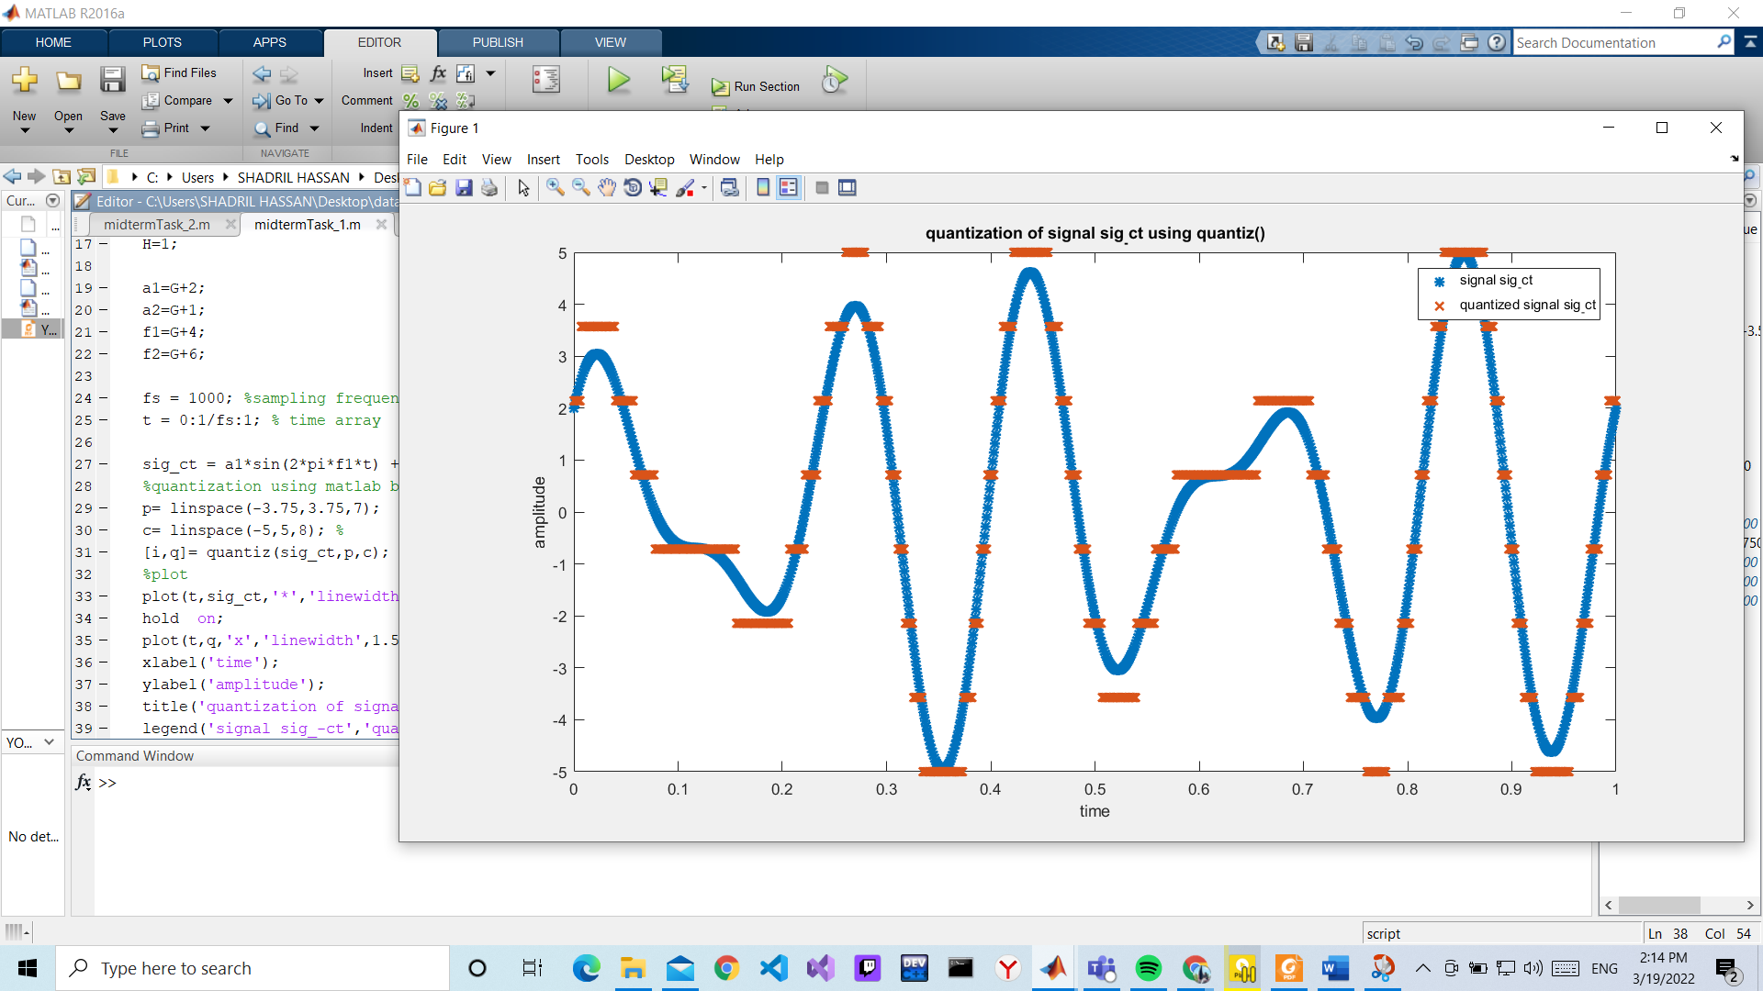

**2.** Apply **uniform quantization** of **4** levels on **sig_ct not using** Matlab built in function  
**quantiz()**. The quantized levels must be in the midpoint of each of the quantization ranges.  
Show approximately one full cycle of both **sig_ct** and the **quantized signal** in a single  
figure window in time domain. In the report, insert the code as text and attach the figure.  
**Legend, labels**, and **title** are mandatory. Use ‘**\***’ marker for **sig_ct** and ‘**x**’ marker for the  
**quantized signal**. Use such a sampling frequency value so that the points of **sig_ct** and the  
**quantized signal** are visible clearly and comfortably. (**5**)

**MATLAB Code:**

clc;

clear all;

close all;

%ID= 20-42451-1

A=2;

B=0;

C=4;

D=2;

E=4;

F=5;

G=1;

H=1;

a1=G+2;

a2=G+1;

f1=G+4;

f2=G+6;

fs = 1000; %sampling frequency

t = 0:1/fs:1; % time array

sig_ct = a1*sin(2*pi*f1*t) + a2*cos(2*pi*f2*t);%signal

% manual quantization

level=4;

delta= (max(sig_ct)-min(sig_ct))/(level-1);

xq=min(sig_ct)+(round((sig_ct-min(sig_ct))/delta)).*delta;

% plotting

plot(t,sig_ct,'*','linewidth',1.5);

hold on;

plot(t,xq,'x','linewidth',1.5);

xlabel('time');

ylabel('amplitude');

title('quantization of signal sig_-ct');

legend('signal sig_-ct','quantized signal sig_-ct');

**Output:**

